Problem Statement 1

In an e-commerce company, customers browse the website to place orders for various brands and items. In the process, they must register themselves, sign in with a username and password, search for specific brands and items, and place an order. While placing the order they can add/remove products from the shopping cart, discard the shopping cart, or proceed with the payment using various payment options.

The data stored from all the transactions and activities happening on the website is complex in nature. It could be in structured or unstructured format. It might be in text, document, or JSON format. Being the Database Administrator of your organization, you are responsible to use a database, which has flexible schema, reduces the operational procedure, and is highly scalable and reliable.

Solution:

Downloaded, installed and configured MongodB since it supports flexible schema, reduced operational procedures and high scalability & reliability

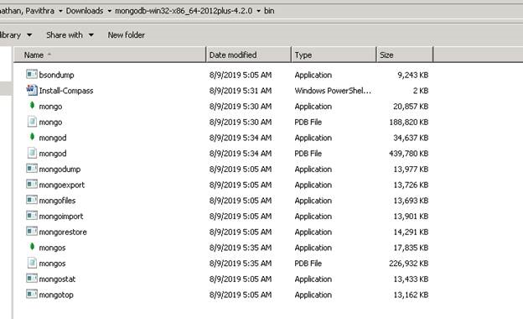

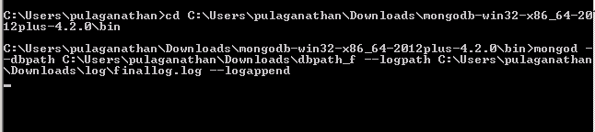

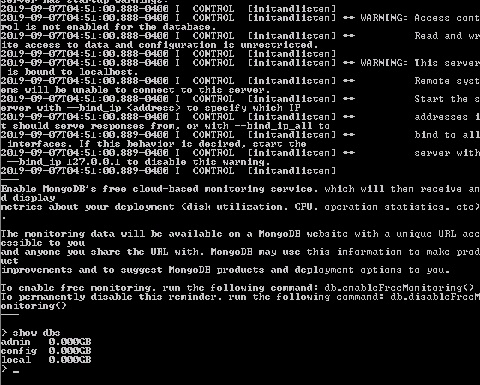

Problem Statement 2

Further after the installation and configuration of the database, you must identify the final data schema. To do so:

• Identify the operations that the system need to support, based on the system functionality

• Identify the entities that the operations 'interact' with

• Identify meta-data of the entities

• View how the entities are used in the system in relation to one another

• Bring it all together by using the findings from the above steps and apply some best practice rules to them.

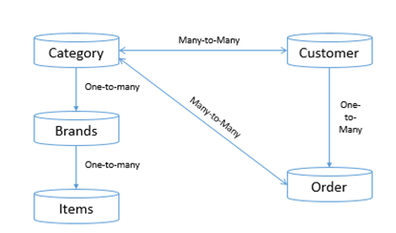

Solution:

Embedded Data modelling should be used when there exists one-to-one or  one-to-many relationships; whereas the Linked/Reference data modelling should be used when there exists many-to-many relationship.

Thus, we can have the below approach followed:

1.       Category, Brands and Items, to be built using Embedded data modelling, by utilizing one single collection for holding all the details. i.e., Category, brands, Items.

Hence, single extraction will give all the output in one shot.

For performing update also, one single update query will update the entire collection.

2.       Customer and Order to be built using Linked/Reference data modelling, by utilizing separate collection since these are bounded to many-to-many relationships

Problem Statement 3

After you create a logical schema, next step is to create a database named as “**Mongo_DB_Project**” which would be handled by a user “Adam”. You must maintain orders, customers and categories of data with brands and items in segregated form. You are also responsible for modifying the documents and removing duplicate or redundant documents.

Solution:

Create Database “**Mongo_DB_Project**” using “use DBName”

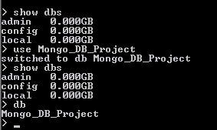

Create User ‘Adam’ with roles

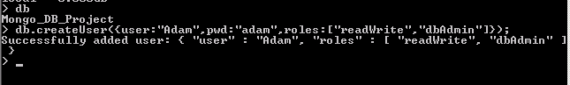

Create 3 Collections – Orders, Customers and Categories

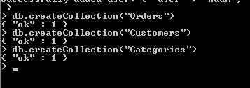

Insert documents in the collections

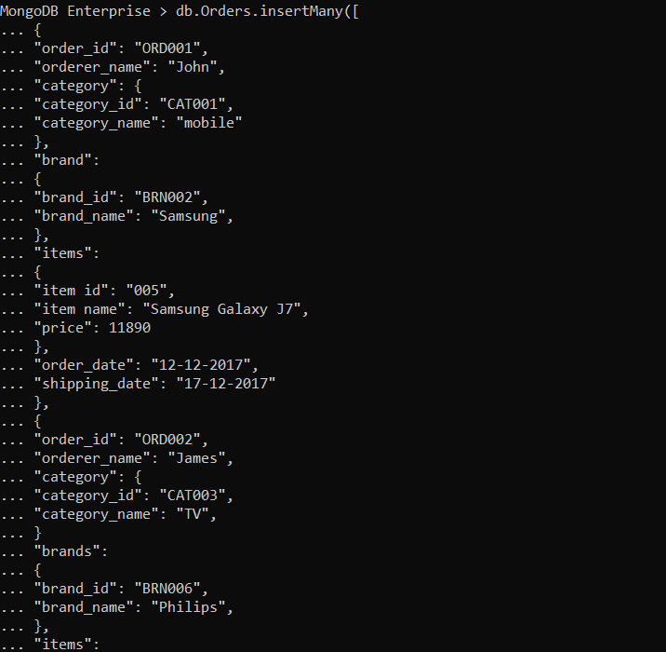

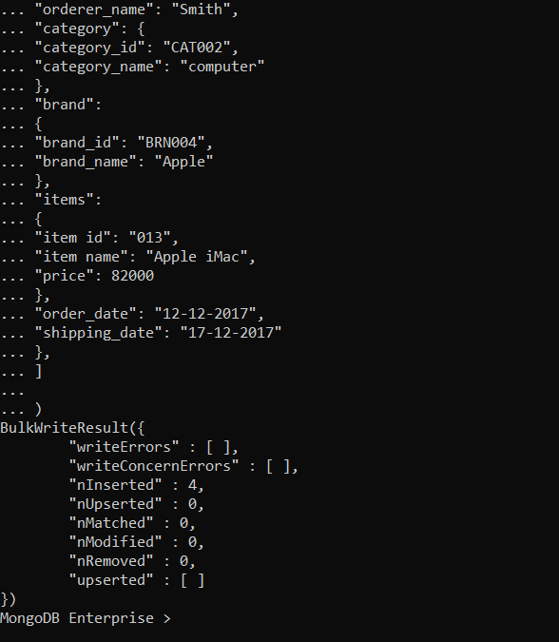

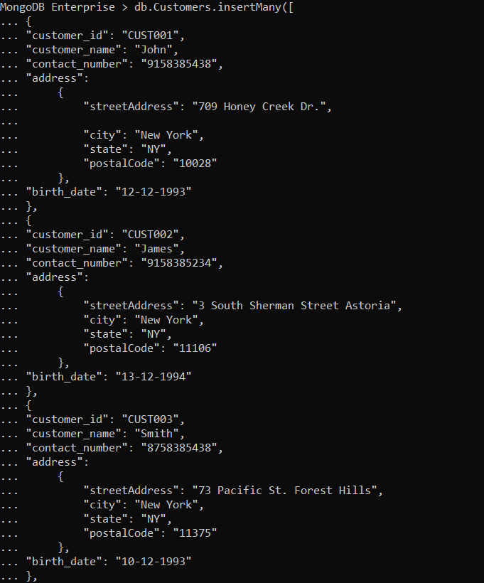

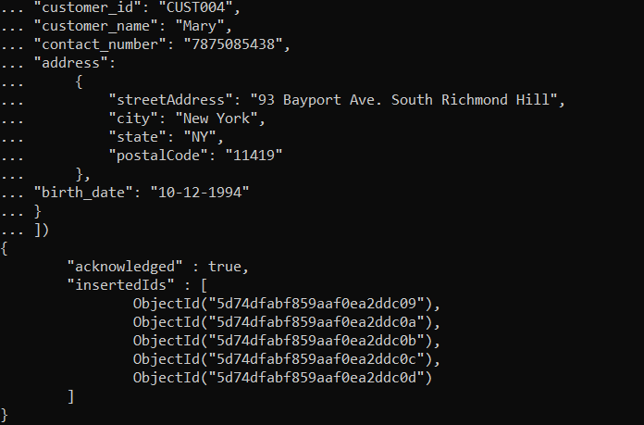

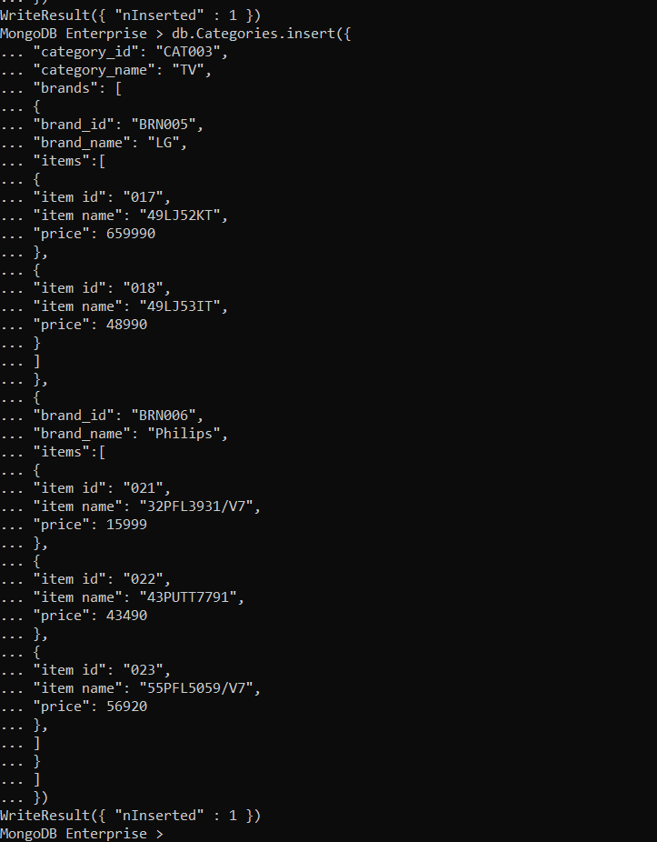

Query data from MongoDB using find command

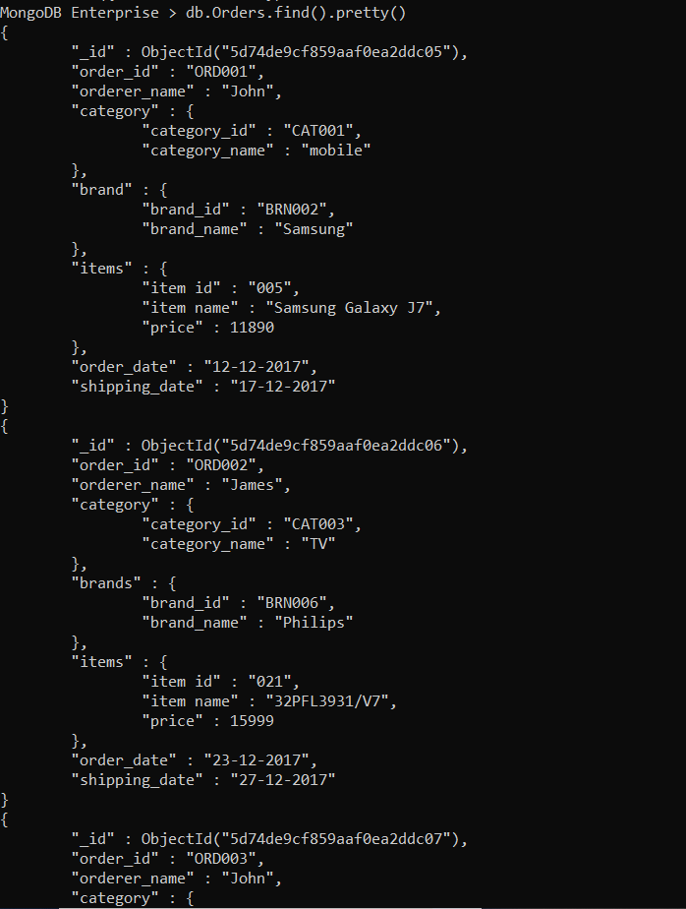

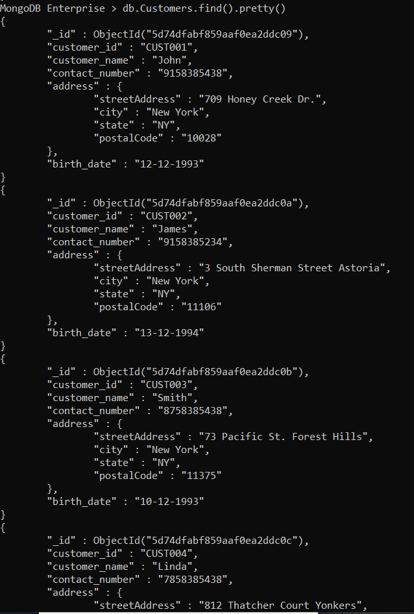

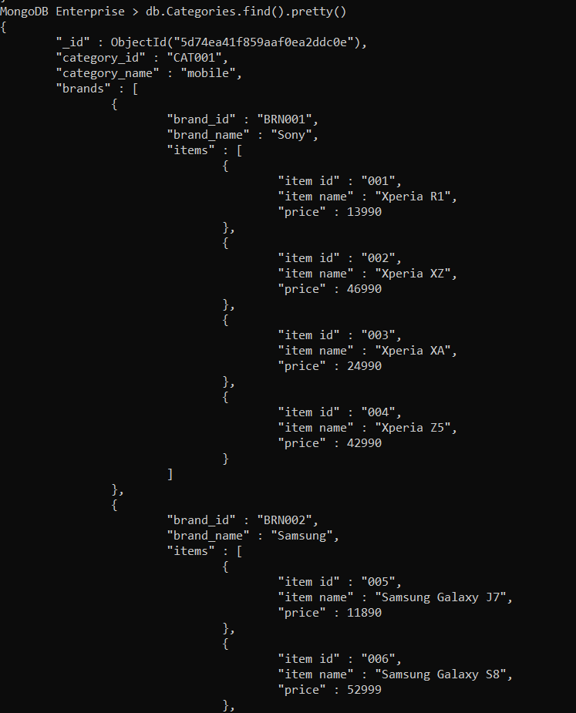

The price of **Dell OptiPlex** computer has increased from 32200 to 33000. Update the document in Category collection accordingly.



Observe the documents to find a duplicate document with different order_id &

Delete the duplicate document(s)

**db.Orders.aggregate(**

**{"$group" : { "_id": "$order_id", "count": { "$sum": 1 } } },**

**{"$match": {"_id" :{ "$ne" : null } , "count" : {"$gt": 1} } },**

**{"$project": {"name" : "$_id", "_id" : 0} }**

**)**

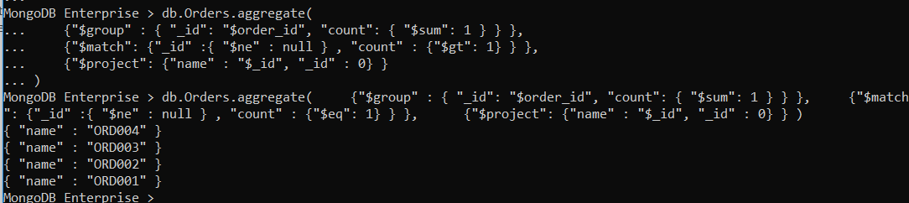

**No duplicates found**

Problem Statement 4

Your organization keeps consolidated data in a single file for all categories with distinct brands and items for each brand with item details. So, you must take a backup of the data.

Solution:

Take backup

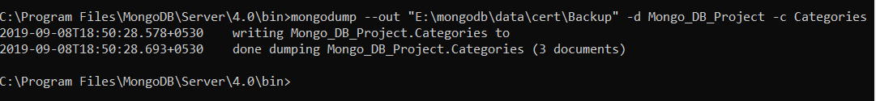

Restore

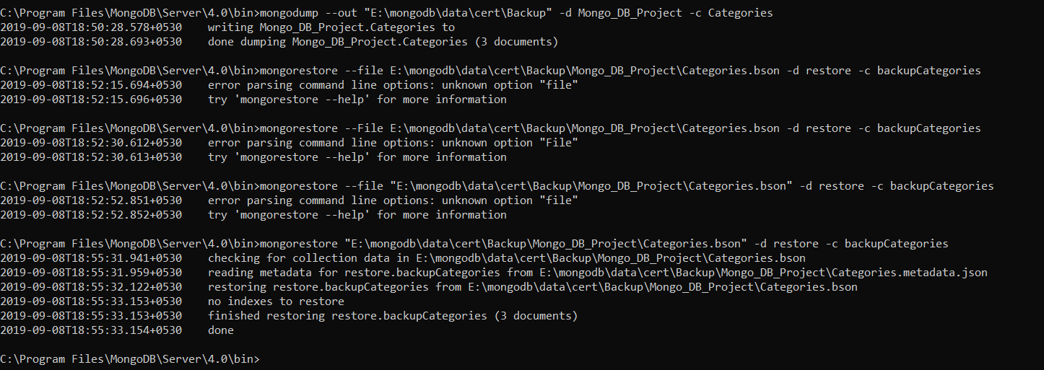

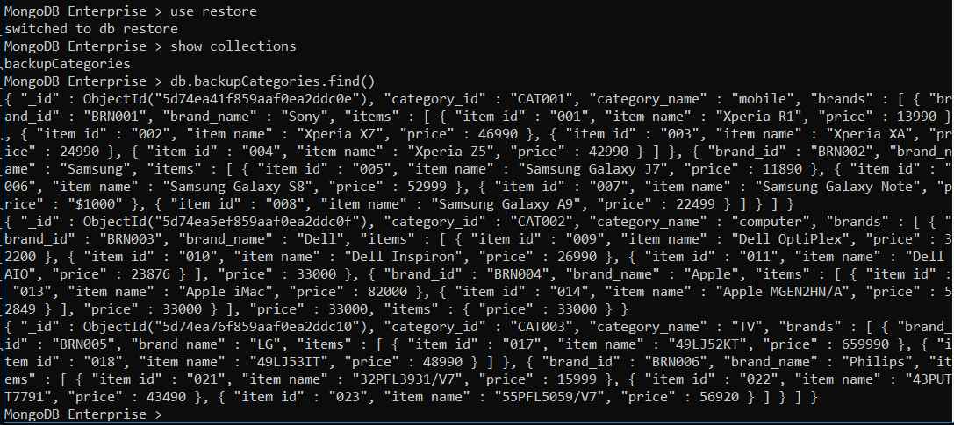

Problem Statement 5

With the increasing data, the query performance of MongoDB has declined. You are responsible for optimizing the query performance of the database. Which steps would you take?

Solution:

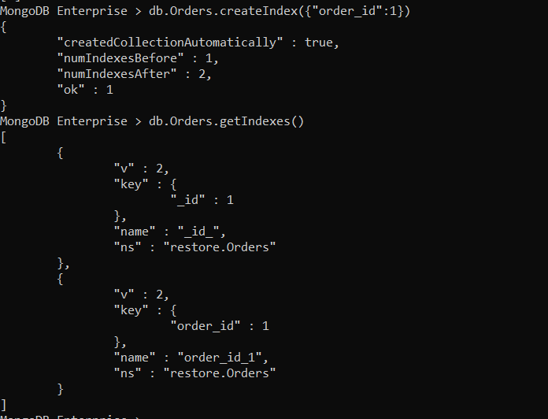

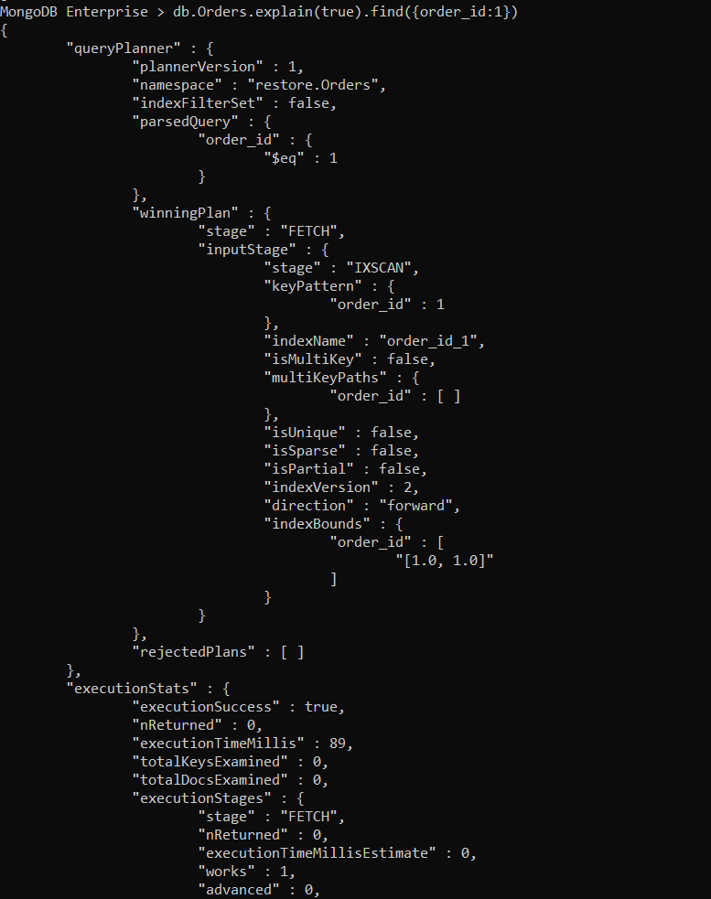

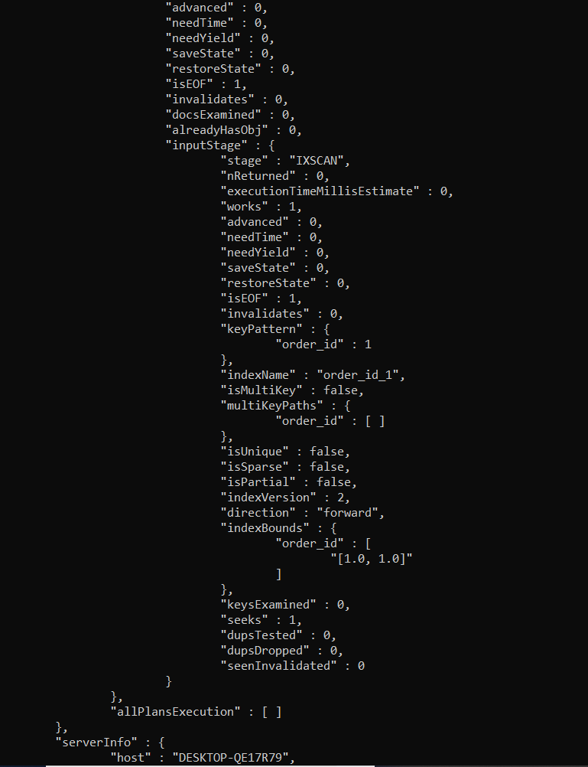

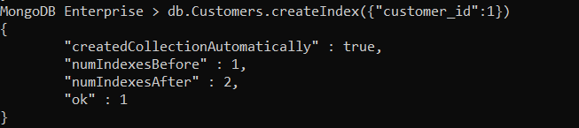



Problem Statement 6

Your manager has asked you to provide total price obtained from order placed for various items.

Solution:

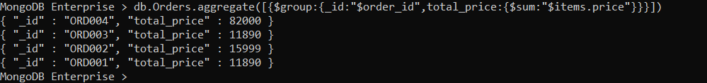

Problem Statement 7

With the modernization of technologies, you should also modernize the storage process of the organizational data to increase flexibility and scalability at reduced cost. So, you decide to host your database somewhere and deploy it to make it secure, fast and highly available for any scale. You suggest your managers that you can save your data in MongoDB Atlas. So, you are now responsible to store your data in MongoDB Atlas and provide security to your cluster.

Solution:

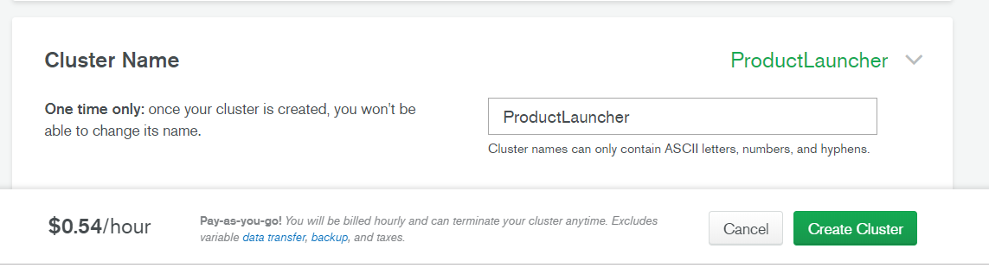

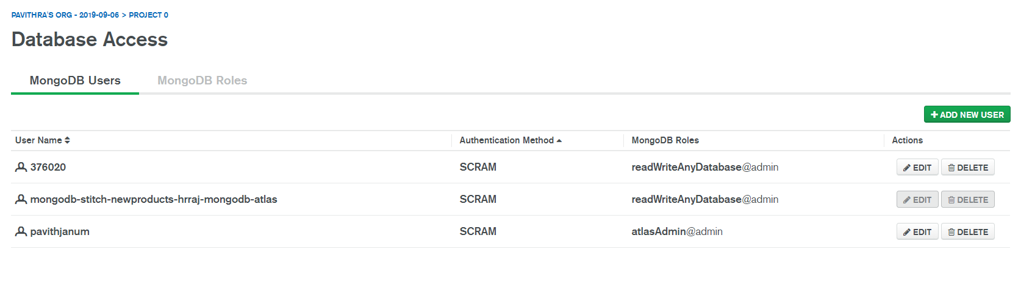

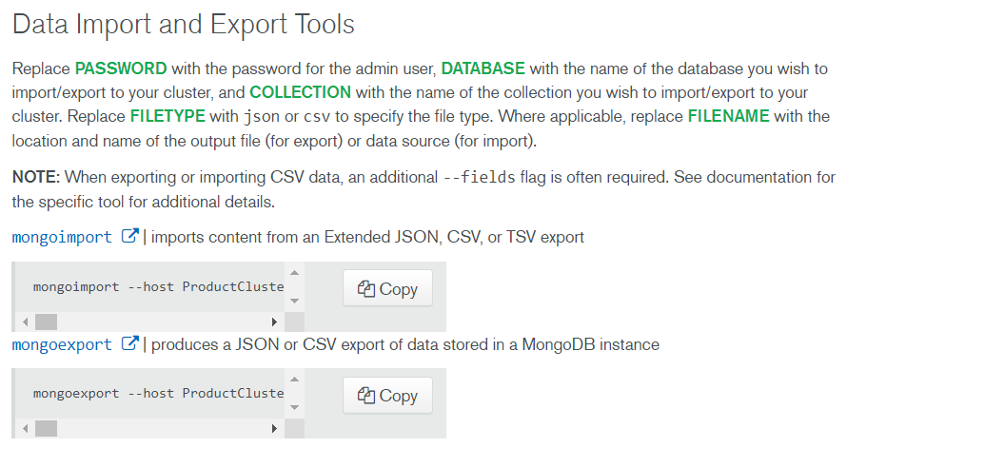



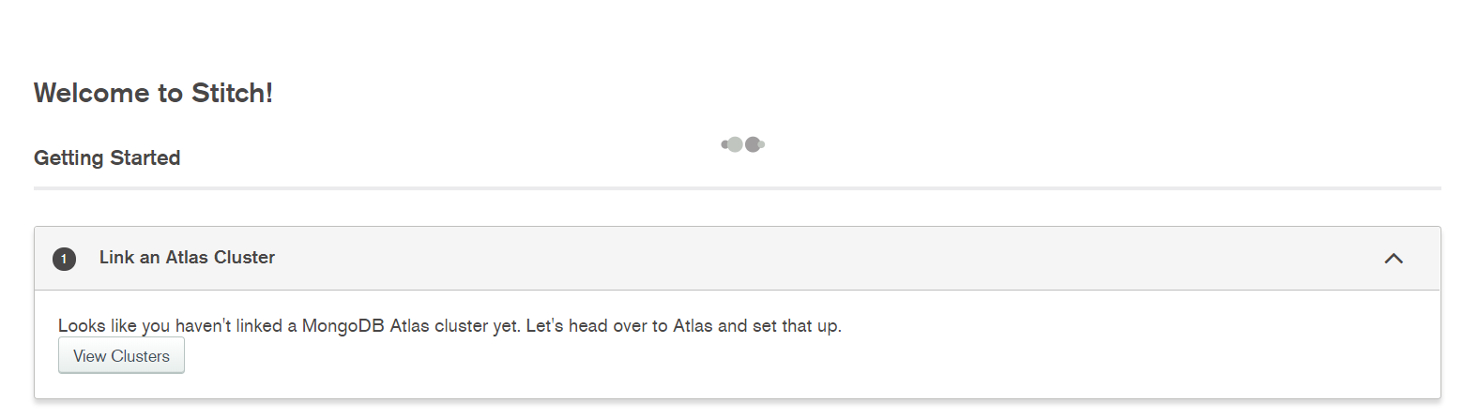

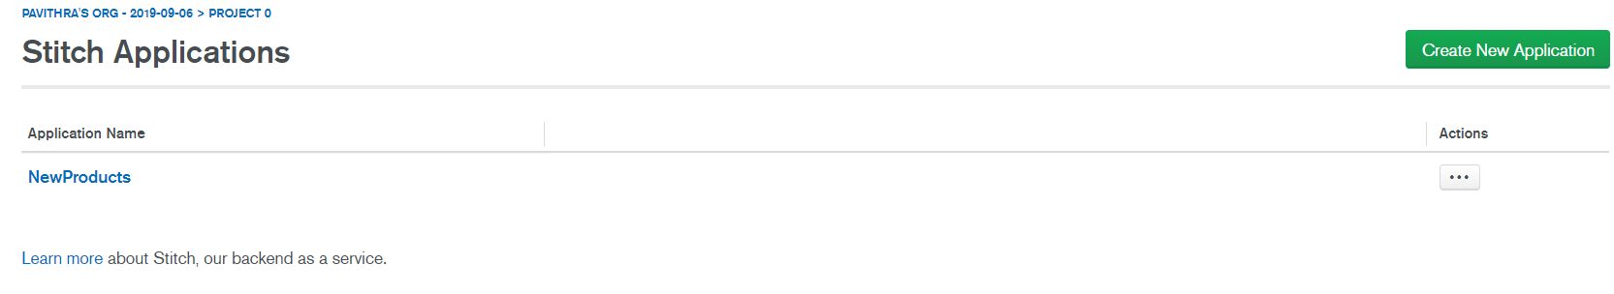

Problem Statement 8

You have a lot of unwanted, empty and invalid collections which are consume the memory space of the server machine. Some users have also complained about some warnings and errors encountered while performing various tasks. What would you do?

Solution:

**db.runCommand( { buildInfo: 1 } ) 🡪 Status of the entire creation task**

**db.runCommand({ serverSatatus:1}) 🡪 current status of the server**

**db.runCommand({ getLog: "global"}) 🡪 Get log of all the activities performed**

**db.runCommand({ getLog: "startupWarnings"}) 🡪 Get log of the activities which encountered some warnings**

**db.oplog.rs.find()**

Problem Statement 9

The developer of your organization has created a new application. You are asked to perform a test for the same application, where you will insert few documents in MongoDB database using a Rest Client.

Solution:

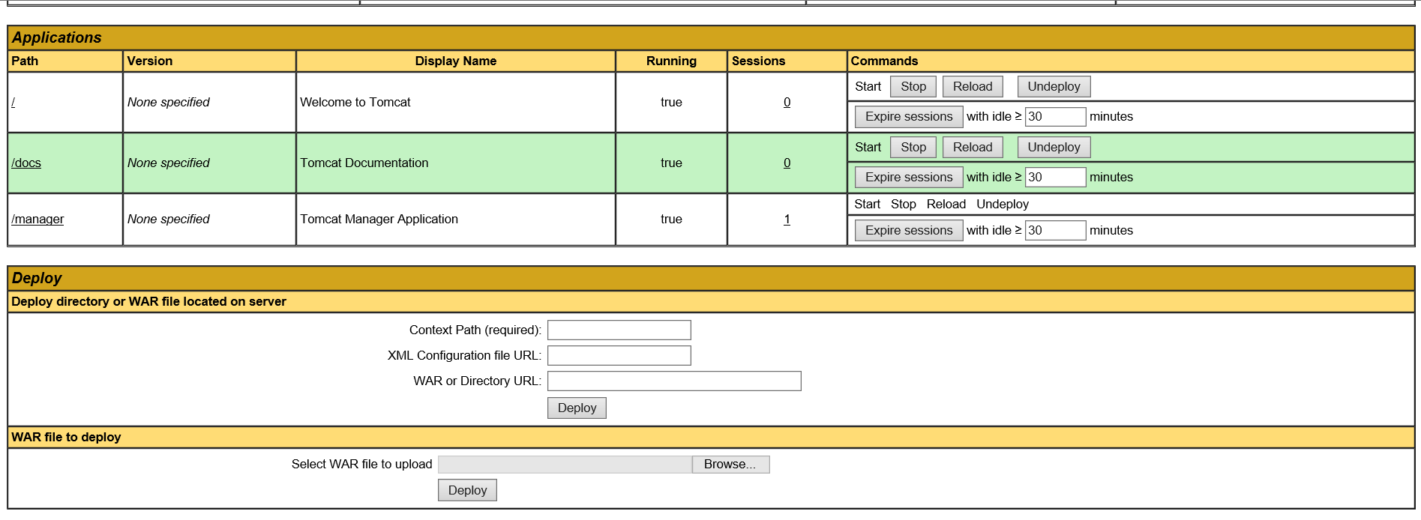

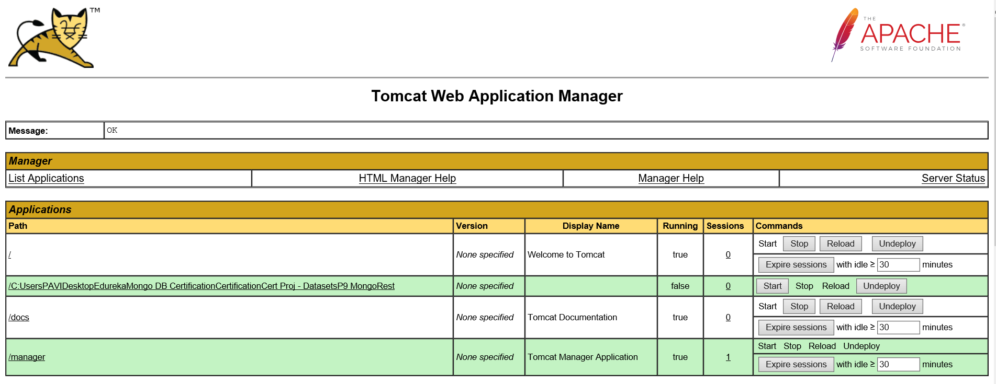

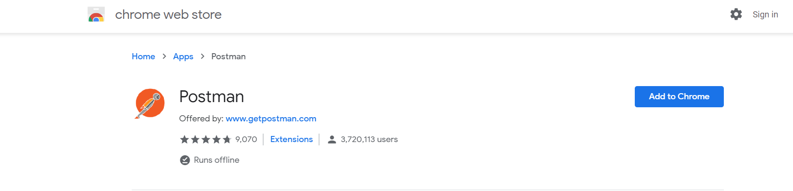

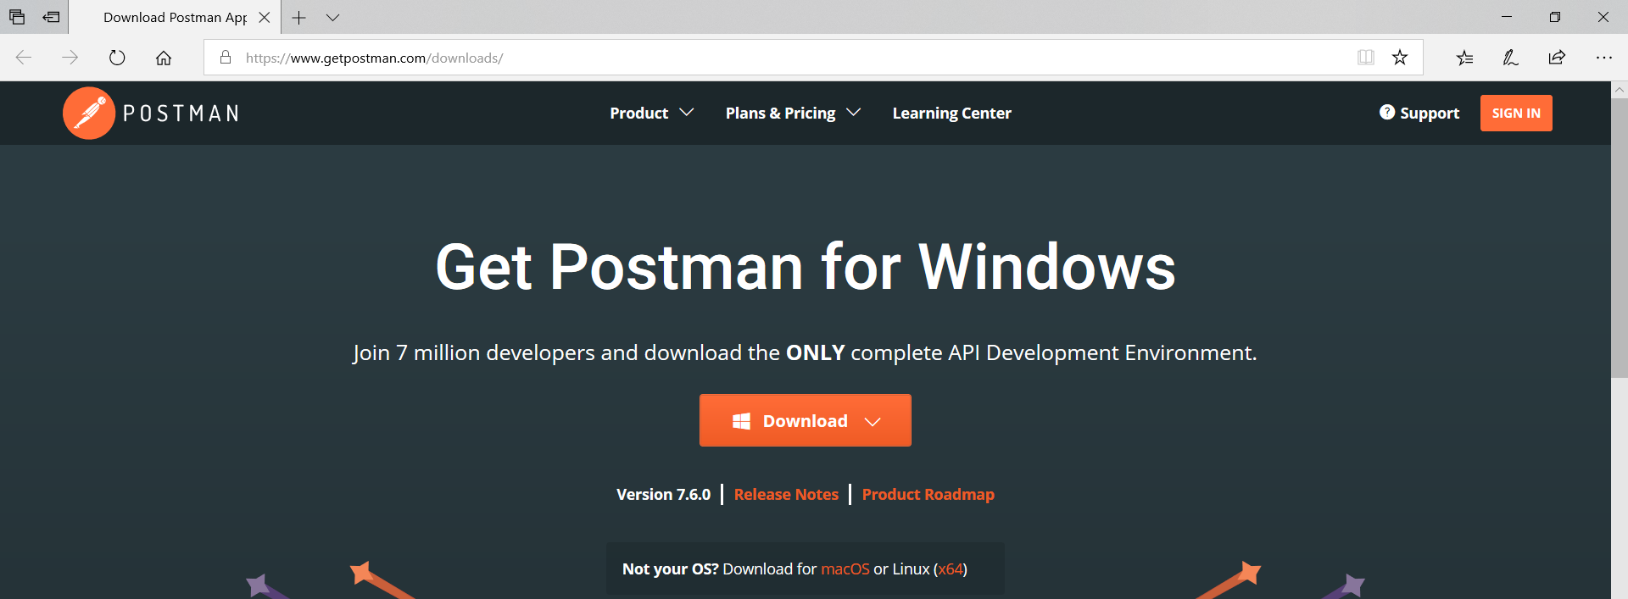

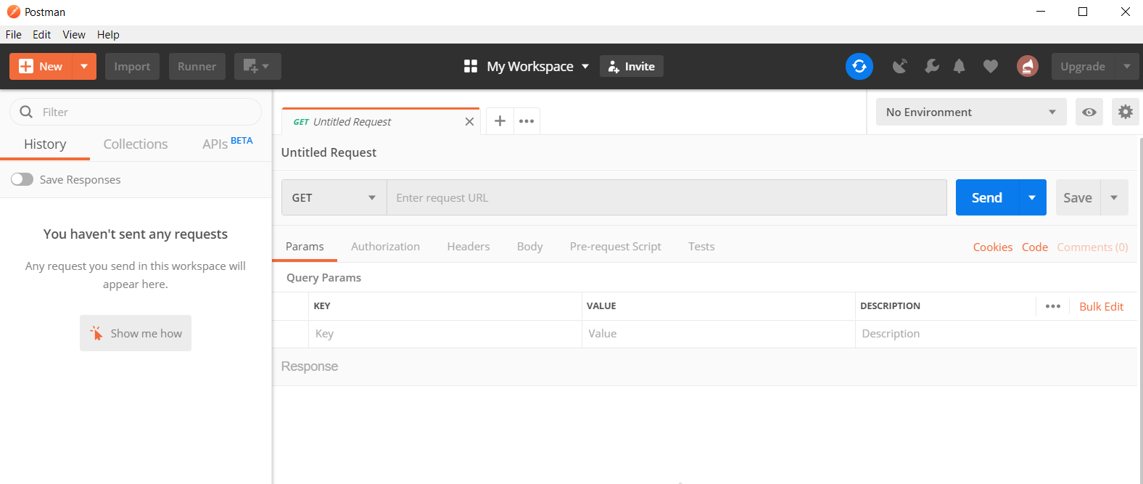

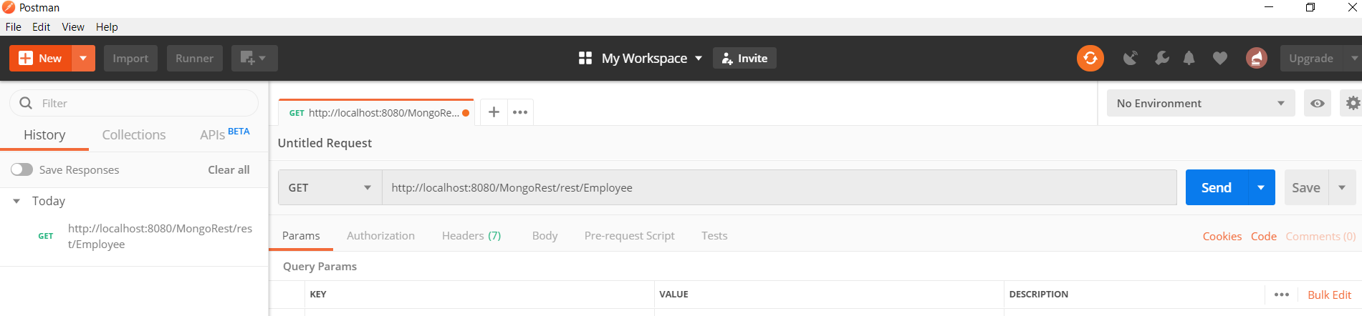

Problem Statement 10

As a database Administrator, you must be well prepared to face situations like system failure, disaster management recovery. You should have replica sets created of your server database.

Solution:

